ROYAL OAK INTERNATIONAL SCHOOL
Sr. Sec. C.B.S.E Affiliated
SESSION: 2019-20
Whole year syllabus of CLASS-VIII

SUBJECT-ENGLISH

Month | Days | Content | Activities | Worksheet
Apr. | 20 | Literature: L-1 The Eyes Have It L-2 When you are old(Poem)  Writing: Formal Letter  Grammar: Verbs( transitive& Intransitive) &Modals ( Editing/Omission)  Novel : Ch-1 &2
May | 8 | Literature: L-3 The Black Spot Writing: Notice  Grammar: Non Finite Verbs & Prepositions ( Editing/Omission)  Novel : Ch-3
July | 24 | Literature: L-4 The Nightingale and the Glow worm(Poem)  L-5 After twenty Years L-6 The way through the woods.  Writing: Informal Letter & Diary Entry  Grammar: Subject Verb Agreement &Tenses( Present & Present)  Novel : Ch-4,5,6&7
Written Evaluation Syllabus: P.A - IM.M. 40
Lit: L-1to3 Writng: Notice & Formal Letter Grammar: Integrated Grammar(Verbs, Modals & Preposition )
Reordering of sentences. Novel : Ch-1 to 3
Aug. | 25 | Literature: L-7 The Remarkable Rocket L-8 The Open window  L-9 A Nation’s strength (Poem)  Writing: Story Writing & Dialogue completion  Grammar: Kinds of Sentences & Phrases, Clauses  Novel : Ch-8
Sept. | 4 | Grammar: Tenses( Future)
Written Evaluation Syllabus Half Yearly Exam M.M 80
The Syllabus covered from April’19 to August’19
Oct. | 19 | Literature: L-10 Pride and Prejudice L-11 The Potrait of a lady  Writing: Poster & Advertisement ( Sale & Purchase)  Grammar: Narration and Adverb  Novel : Ch-9 & 10
Nov. | 14 | Literature: L-7 The Remarkable Rocket L-8 The Open window  L-9 A Nation’s strength (Poem)  Writing: Story Writing & Dialogue completion  Grammar: Kinds of Sentences & Phrases, Clauses  Novel : Ch-8 &9 10
Written Evaluation Syllabus P.A. – II M.M 40
L-10, L-11, L-13 Writing : Story writing , poster making, advertisement Grammar :Kinds of sentences, Narration, Conjunction Novel : Ch-11
Dec. | 19 | Literature: L- 14: From storytelling to film making  L- 15: I go to styles.  Writing : E-mail writing  Grammar : Synthesis of sentences, narration
Jan. | 18 | Literature: L- 16 Three witches and their properly  Writing : Factual description  Grammar : Editing, Omission
Feb. | 10 | Revision of whole syllabus for yearly exam
Written Evaluation Syllabus : Yearly exam M.M. 80
whole syllabus
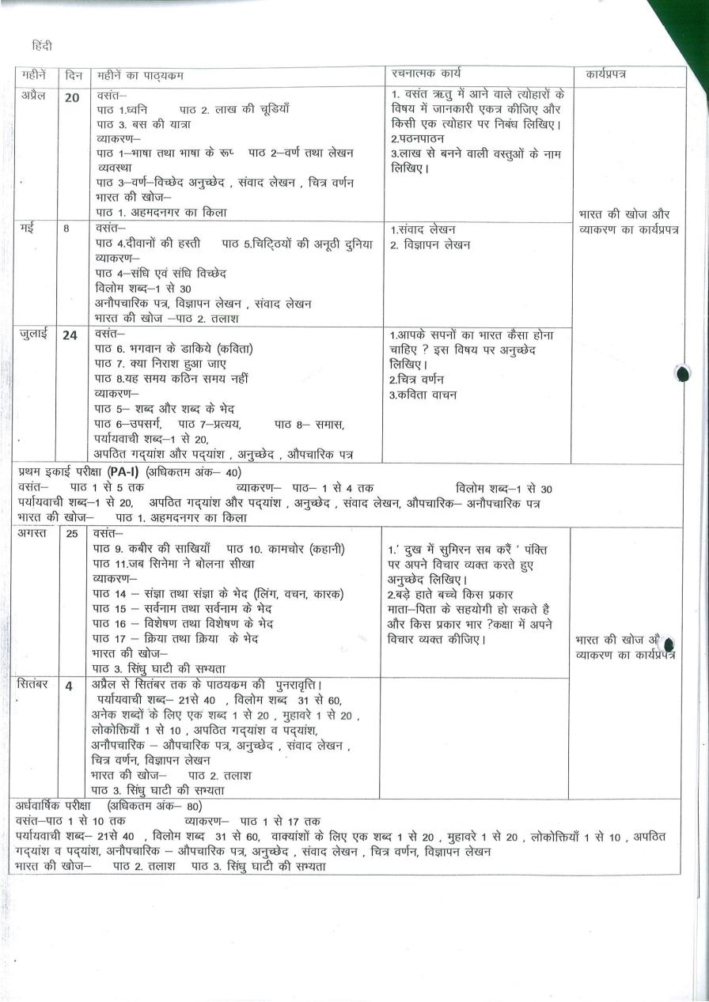
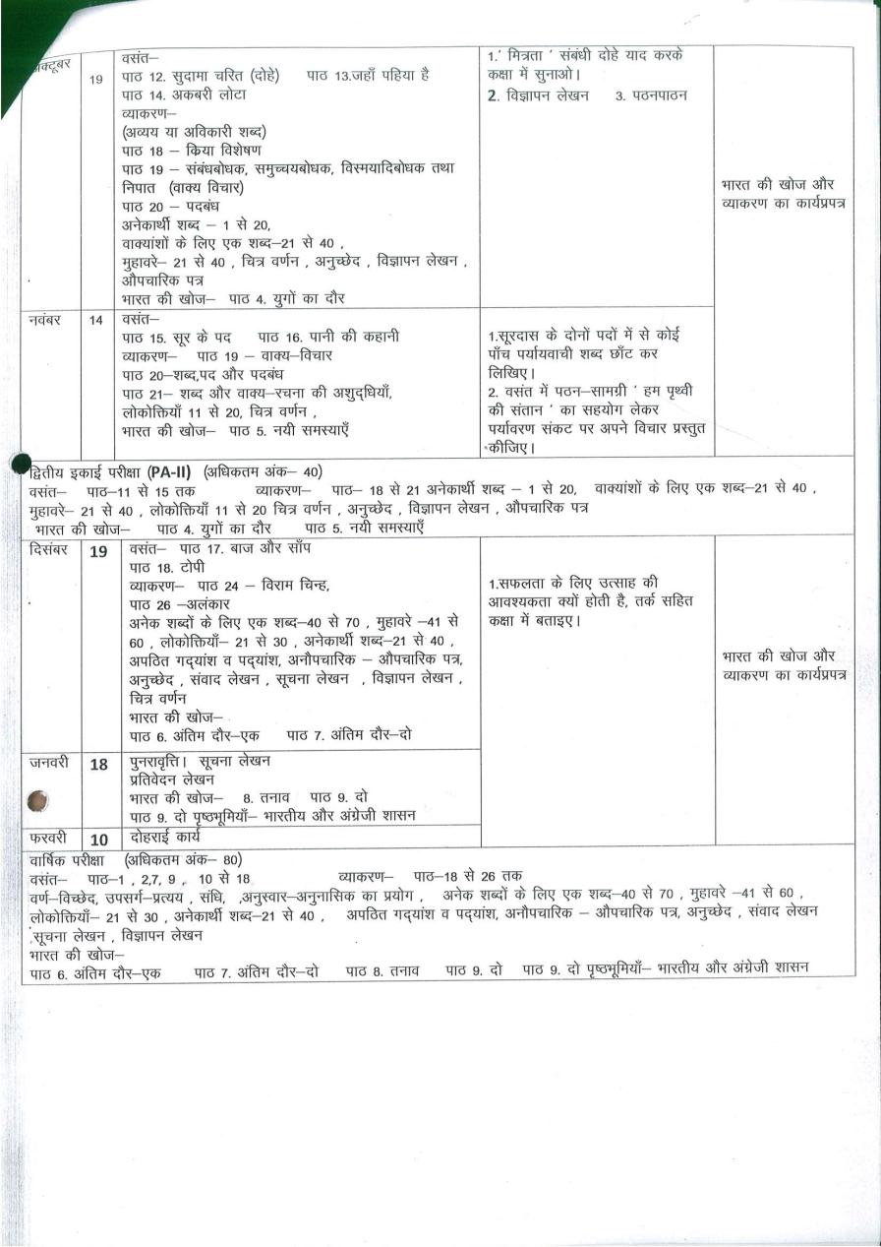
Maths
Month | Content | Chapters covered by Activities(In Maths-lab Mannual ) | Work sheet
Apr.  (20) | Ch :-1 Rational numbers | Activity 1: To find the sum of fraction with different denominator | Solve Drill exercise book by APC given in book set by the school
May & Jul.  (8+25) | Ch: -2 Linear Equation in one Variable,  Ch: -3Understanding of Quadrilaterals,  Ch: -4 Practical Geometry. | Activity 2: To form various polygons by paper folding and to identify convex & concave Polygons  Activity 3: To make a parallelogram, square, rectangle & trapezium by using set squares . | Solve Drill exercise book by APC given in book set by the school
WRITTEN EVALUATION SYLLABUS : P.A. – I M.M. 40
Ch : - 1 Rational numbers Ch : - 2 Linear Equation in one Variable Ch: -3 Understanding of Quadrilaterals Ch: -4 Practical Geometry.
Aug. & Sept  (23+22) | Ch: -5Data handling ,  Ch: -6 Square and square Root, Ch: -7Cube And Cube Roots ,  Ch: -8Comparing Quantities. | Activity 4: To obtain angle bisector of an angle by paper folding . | Solve Drill exercise book by APC given in book set by the school
WRITTEN EVALUATION SYLLABUS : Half Yearly Exams M.M. 80
All the Chapters.Ch 1 to Ch .8
Oct. & Nov.  (19+21) | Ch: -9 Algebraic Expressions And Identities,  Ch: -10 Visualized Solid Shape, Ch: -11 Mensurations | Activity : 5 To verify the algebraic identity  (a + b)²  = a² + 2ab + b²  Activity 6: To see that shapes having equal areas may not have equal perimeters | Solve Drill exercise book by APC given in book set by the school
WRITTEN EVALUATION SYLLABUS : P.A –II M.M. 40
Ch: -9 Algebraic Expressions And Identities. Ch: -10 Visualized Solid Shape Ch: -11 Menstruations
Dec. & Jan.  (12+23) | Ch: -12 : Exponent and Powers , Ch: -13: Direct and Indirect Proportions  Ch: -14: Factorization. | Activity 7: To draw a perpendicular on a line from a point not on it . | Solve Drill exercise book by APC given in book set by the school
Feb.  (21) | Ch:-15 Introduction to graphs  Ch:-16 Playing with numbers | Activity : 8 To verify the algebraic identity  (a - b)² = a² - 2ab + b² | Solve Drill exercise book by APC given in book set by the school
WRITTEN EVALUATION SYLLABUS : Yearly Exam : 80
All the Chapters (Ch .No -1 to Ch .no 16)

Science
Month | Days | Chapters To be covered | Activity/ Practical’s | Chapters in the  form of Assignment
April | 18 | Ch.1 Crop production and management  Ch.2 Microorganism friends or foe  Ch.5 Coal and petroleum
May | 8 | Ch.5 Coal and petroleum (cont.)  Ch.4 Materials : Metals and Non metals |  | Ch.3 Synthetic fiber  And plastics  (Assignment)
July | 10 | Ch.6 Combustion and flames  Ch.7 Conservation of plants and animals
WRITTEN EVALUATION SYLLABUS : PA I M.M 40
Ch.1, .2, .4, 5, .6
Aug. | 21 | Ch. 8 Cell- Structure and Functions  Ch.9 Reproduction in animals
Sep. |  | Revision
WRITTEN EVALUATION SYLLABUS : Half Yearly M.M (80)
Ch.1, .2, .4, 5, 6, 7, 8, 9
Oct. | 17 | Ch. 11 Force and pressure  Ch.12 Friction  Ch. 13 Sound | Ch. 10 Reaching the  age of Adolescence  ( assignment )
Nov. | 9 | Ch. 13 Sound (cont.)  Ch.14 Chemical effect of electric current
WRITTEN EVALUATION SYLLABUS : PA II M.M 40
Ch. 11, .12, 14, 15, 16
Dec. | 20 | Ch. 15 Some natural phenomena  Ch. 16 Light |  | Model of  Solar system
Jan. | 19 | Ch. 17 Stars and the Solar System  Ch. 18 Pollution of Air and Water
Feb. |  | Revision
WRITTEN EVALUATION SYLLABUS : Yearly Exam M.M (80)
Ch. 11, .12, 13, 14, 15, 16, 17, 18, 2 6

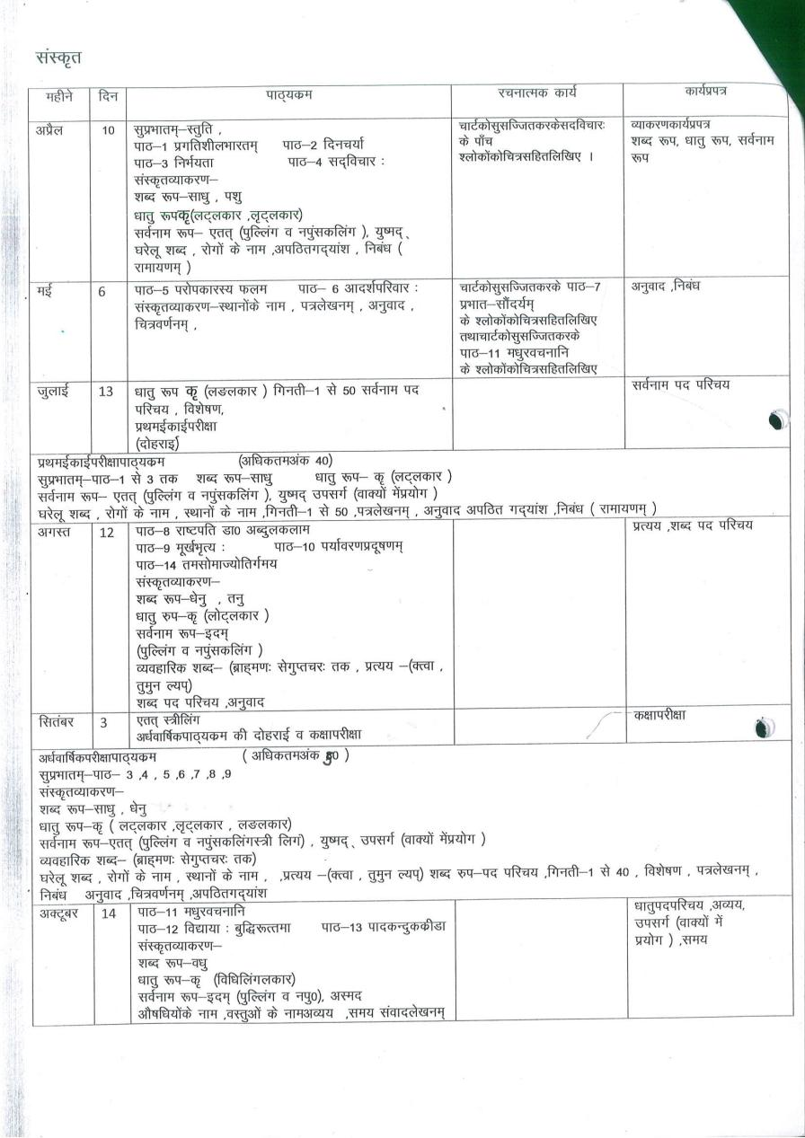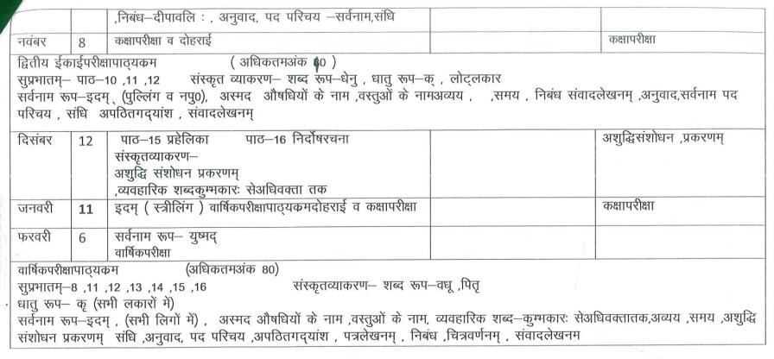
Social Studies
Month | Days | Chapters To be covered | Activity | Worksheet Chapter wise
April | 25 | Geo. L-1 Resource ,  L-2 Natural vegetation and wildlife  Pol. L-1 The Indian Constitution | His. L-1How,When  and & Where  L- 9 Women  and reforms  Pol. L-9 Public Facilities  L-10 Law and  social justice  Diagrams ,  Crosswords ,  Flow Charts,  Map work,  posters ,  Brochures ,  Debate &  Group  Discussion  ( as per the  requirement  of the  chapter ) | Assignments  &  worksheets  (as per  Requirement  of the chapter  will be  provided)
May | 8 | His. L-2 From trade to territory
July  (Exams) | 25 | Pol. L-2 Understanding Secularism  L-3 Why do we need a Parliament  Geo. L-3Minerals and power resources
WRITTEN EVALUATION SYLLABUS : PA I M.M (40) 4 chapters
H – 2 G- 1,2 P- 1
Aug. | 21 | His. L-3 Ruling the countryside  Geo. L-4 Agriculture  Pol. L-4 Understanding Laws
Sep | 21 | Pol. Science L-5 Judiciary
WRITTEN EVALUATION SYLLABUS : Half Yearly M.M (80)
8 chapters H – 2,3 G–1,3,4 P- 1,3,4
Oct. | 19 | Geo. L-6 Human Resource  His. L-5 When people Rebel
Nov.  (Exams) | 21 | Geo. L-5 Manufacturing Industries  Pol. L-6 Understanding Our criminal  justice system
WRITTEN EVALUATION SYLLABUS : PA II M.M (40) 4 chapters
H-5 G- 5 P- 5,6
Dec. | 20 | His. L-11 The making of the National Movement
Jan. | 20 | His. L-12 India after Independence
Feb. | 11 | Revision
WRITTEN EVALUATION SYLLABUS : Yearly M.M (80)
Whole syllabus (April – January)

Computer
Month |  | No. of Days |  | Content | Practical
April |  | 18 |  | Ch – 1 : Introduction to Access 2016 | MS Access : creating a database, setting data types, modifying table design, totaling, sorting, filtering and searching data
May |  | 8 |  | Ch – 2 : Access 2016 : Design View,  Queries, Forms and Reports | MS Access : creating table in design view, queries, forms, reports
July |  | 10 |  | Ch – 3 : Cutting edge technology  PA-I:(Ch-1 and Ch-2) | Practical for MS-Access 2016
WRITTEN EVALUATION SYLLABUS : PA-I M.M 30
(Ch-1 and Ch-2)
Aug | 20 |  |  | Ch – 5 : Lists and Images in HTML5  Ch – 6 : Tables , Links and Frames in HTML 5 | HTML : Creating lists, Nesting lists, inserting images
Sep |  |  |  | Revision | HTML : creating tables, linking, inserting Audio & video, creating frames
WRITTEN EVALUATION SYLLABUS : Half Yearly Exam M.M 80
(Ch- ,2 ,3 ,5and 6)
Oct | 17 |  |  | Ch – 7 : Introduction to  Photoshop  Ch-8: Tools used in Photoshop | Photoshop : selection tools, working with images, painting & drawing tools
Nov | 9 |  |  | Ch – 9 : Editing with open shot | Photoshop : retouching tools , working with layers, text, using filters
WRITTEN EVALUATION SYLLABUS : PA-II: M.M 30
(Ch-7 and Ch-8)
Dec | 20 |  | Ch – 4 : Introduction to C++ |  | Quick startup. Use of Constant, variable and data type in C++ Programs
Jan | 19 |  | Ch –4 : Introduction to C++ |  | Coding with different Operator
Feb |  |  | Revision
WRITTEN EVALUATION SYLLABUS : Yearly Exam M.M 80
(Ch-7 ,8 ,9 and 4)

Art & Craft
Month | No. of Days | Pages of Art Book | Activity
April | 20 | Bird Study | Stencil work
May | 8 | Animal Study
July | 24 | Landscape Life Study
August | 25 | Sketching | Collage art
September | 4 | Revision
Half yearly --- animal study , life study, sketching,bird study
October | 19 | Portrait
November | 14 | Composition
December | 18 | Folk Art Object study | Craft work
January | 10 | Calliography
February |  | Revision
Yearly – folk art,composition,object study,craft work

